**A PRELIMENERY REPORT ON**

# HOME AUTOMATION OVER THE CLOUD

SUBMITTED TO THE MUMBAI UNIVERSITY, MUMBAI IN THE PARTIAL FULFILLMENT OF THE REQUIREMENTS FOR THE AWARD OF THE DEGREE

OF

# BACHELOR OF ENGINEERING (INFORMATION TECHNOLOGY)

SUBMITTED BY **todo!()**

MR. VERMA SHIVAM UDAYSHANKAR (UID 119IT1246A) MR. SHELKE GAURAV ANIL (UID 119IT1044A)

MR. SAMANI ARSHAD AHMED (UID 119IT1027A)

MS. PANDEY DIPTI VRIJESH (UID 120IT3357B)

Under the Guidance of

**Prof. P. Manivannan**



# DEPARTMENT OF INFORMATION TECHNOLOGY MGM’S COLLEGE OF ENGINEERING AND TECHNOLOGY

**KAMOTHE, NAVI MUMBAI - 410 209**

UNIVERSITY OF MUMBAI

**(AY 2022-23)**

## CERTIFICATE

This is to certify that the Project report entitled “**HOME AUTOMATION OVER THE CLOUD**”

Submitted by **todo!()**

MR. VERMA SHIVAM UDAYSHANKAR (UID 119IT1246A) MR. SHELKE GAURAV ANIL (UID 119IT1044A)

MR. SAMANI ARSHAD AHMED (UID 119IT1027A)

MS. PANDEY DIPTI VRIJESH (UID 120IT3357B)

is a bonafide student of this institute and the work has been carried out by him/her under the supervision of Prof. P. Manivannan and it is approved for the partial fulfillment of the requirement of Mumbai University, for the award of the degree of Bachelor of Engineering (Information Technology).

**Prof. P. Manivannan**

Guide

Department of Information Technology

**Dr. Swati Sinha Dr. Geeta S. Lathkar**

Head Director

Department of Information Technology MGMCET, Navi Mumbai

## PROJECT REPORT APPROVAL

**todo!()**

This Project entitled “**HOME AUTOMATION OVER THE CLOUD**” by **Verma Shivam Udayshankar (UID-119IT1246A), Samani Arshad Ahmed Nafis Ahmed (UID 119IT1027A), Shelke Gaurav Anil (119IT1044A), Pandey Dipti Vrijesh (120IT3357B)** is approved for the degree of Bachelor of Engineering in Information Technology.

**Examiners**

### 1.……………………………………

External Examiner

**2……………………………**

Internal Examiner

Place: Kamothe Date:

## DECLARATION

We declare that this written submission represents our ideas in our own words and where other’s ideas or words have been included, we have adequately cited and referenced the original sources. We also declare that we have adhered to all principles of academic honesty and have not misrepresented or fabricated or falsified any idea/data/fact/source in our submission. We understand that any violation of the above will be cause for disciplinary action by the institute and can also evoke penal action from the source which has thus not been properly cited or from whom proper permission has not been taken when needed.

**todo!()**

|  |  |  |  |
| --- | --- | --- | --- |
| Sr. no | Name of Student | UID | Signature |
| 1 | VERMA SHIVAM UDAYSHANKAR | 119IT1246A |  |
| 2 | SAMANI ARSHAD AHMED | 119IT1027A |  |
| 3 | SHELKE GAURAV ANIL | 119IT1044A |  |
| 4 | PANDEY DIPTI VRIJESH | 120IT3357B |  |

Place: Kamothe Date:

## ACKNOWLEDGEMENT

**todo!()**

The success and outcome of this project required a lot of guidance and assistance from many people and we are extremely fortunate to have got this all along with the completion of our project work. Whatever we have done is only due to such guidance and assistance and we would not forget to thank them. It is a matter of great pleasure for us to submit the project report on “**HOME AUTOMATION OVER THE CLOUD**” as a part of our curriculum.

First and foremost, we would like to thank our Director Dr. Geeta S. Lathkar, for giving us an opportunity to do the project work. We would like to thank our H.O.D and teachers for the valuable guidance and advice. To inspire us greatly to work on this project and willingness to motivate us contributed tremendously to our project.

And finally, a special thanks goes to my team members, who helped me to assemble the information and gave suggestions to complete our project.

# ABSTRACT

This paper introduces a MERN stack-based web platform designed to connect farmers, consumers, and sellers, with the primary aim of facilitating direct exchanges of agricultural products. The platform enables farmers to list and promote their produce, consumers to browse and purchase locally-sourced items, and sellers to market agricultural supplies. The MERN stack technology ensures scalability and responsiveness, offering a user-friendly interface for all participants.

The website's core objective is to eliminate intermediaries in the agricultural supply chain, fostering more efficient and transparent transactions. By promoting direct sales and reducing overhead, this platform empowers farmers, benefits consumers with access to fresh local products, and offers sellers a dedicated agricultural clientele. The potential impact includes a more sustainable, equitable food system and improved agricultural sustainability.

In summary, this paper presents a technology-driven solution to bridge the gap between farmers, consumers, and sellers in the agricultural market, offering a user-friendly and efficient platform to promote direct transactions and enhance the quality and sustainability of the agricultural supply chain.

# TABLE OF CONTENTS

**todo!()**

|  |  |  |  |
| --- | --- | --- | --- |
| **Chapter No.** | **Title** | | **Page No.** |
|  | **Abstract** | | **iii** |
|  | **List of Figures** | | **v** |
| **1** | **Introduction** | | **1** |
|  | 1.1 | Objectives | **2** |
|  | 1.2 | Scope | **3** |
| **2** | **Literature Survey** | | **4** |
| **3** | **Design & Implementation** | | **6** |
|  | 3.1 | Hardware Analysis | **6** |
|  | 3.2 | Software Analysis | **8** |
|  | 3.3 | Components, Connection &Working | **9** |
|  | 3.4 | Block Diagrams | **12** |
|  | 3.5 | Circuit Diagrams | **13** |
|  | 3.6 | Code | **14** |
| **4** | **Results And Outputs** | | **25** |
|  | 4.1 | Outputs & Screenshots | **25** |
| 4.2 | Applications | **30** |
| 4.3 | Result | **31** |
| **5** | **Conclusion and Future Works** | | **32** |
| **6** | **References** | | **33** |

**List of Figures**

|  |  |  |
| --- | --- | --- |
| **Fig.No** | **Title** | **Pg. No** |
| **1.1** | Block Diagram of Smoke Detection System | **12** |
| **1.2** | Block Diagram of Motion Controlled Led Lights | **12** |
| **1.3** | Block Diagram of Password Based Door Lock System | **13** |
| **2.1** | Circuit Diagram of Smoke Detection System | **13** |
| **2.2** | Circuit Diagram of Motion Controlled Led Lights | **14** |
| **2.3** | Circuit Diagram of Password Based Door Lock System | **14** |
| **3.1** | Smoke Detection System – Tinkercad 1 | **25** |
| **3.2** | Smoke Detection System – Tinkercad 2 | **25** |
| **3.3** | Smoke Detection System – Hardware 1 | **26** |
| **3.4** | Smoke Detection System – Hardware 2 | **26** |
| **4.1** | Motion Controlled Led Lights – Tinkercad 1 | **27** |
| **4.2** | Motion Controlled Led Lights – Tinkercad 2 | **27** |
| **4.3** | Motion Controlled Led Lights – Hardware 1 | **28** |
| **4.4** | Motion Controlled Led Lights – Hardware 2 | **28** |
| **5.1** | Password Based Door Lock System – Tinkercad 1 | **29** |
| **5.2** | Password Based Door Lock System – Tinkercad 2 | **29** |

# CHAPTER 1 INTRODUCTION

Home automation is a general term that covers a variety of technological capabilities you can install in your home. Home automation can include controlling aspects of your home remotely through a computer or phone, programming electronic devices to respond automatically to certain conditions or scenarios, or centralizing the control of a variety of items in your home into a single control center. In the present time, the technologically advanced world is getting more and more advance as new technology is penetrating deeper into our personal lives even in our homes as well. The home automation system is becoming very popular around the world.

Home automation is used to control and monitor electronic security systems, lighting, climate, appliances, audio and video equipment etc. Home automation is the residential extension of building automation, and it is an automation of the home, housework, or household activity. The benefits of automation are that it is secure and saves money, time, maintenance costs, and makes life easier. Generally, in today’s modern world human beings are addicted to using modern equipment. This project intends to make an Android OS based smart phone or tablet workable for controlling every appliance of industries or households. There are several Android applications available in the market to turn our Android-based smart phone or tablet into a remote control for our home. Time is a very valuable thing. Everybody wants to save time as much as they can. New technologies are being introduced to save our time. To save people’s time we are introducing Home Automation system. With the help of this system, you can control your home appliances like fan, led lights etc. In the computer age of the 21st century, more and more tasks are becoming automated. Automation can make things easier, safer, and often more cost efficient. What was once the stuff of world’s fairs and science fiction is today a reality, so learn about the benefits and capabilities of applying today’s technology to your home. A home automation system typically connects controlled devices to a central hub or “gateway”. The user interface for control of the system uses either wall – mounted terminals, tablet or desktop computers, a mobile phone application, or a Web interface that may also be accessible off-site through the Internet. While there are many competing vendors, there are increasing efforts towards open-source systems. However, there are issues with the current state of home automation including a lack of standardized security measures and deprecation of older devices without backwards compatibility.

Home automation has high potential for sharing data between family members or trusted individuals for personal security and could lead to energy saving measures with a positive environmental impact in the future. In our project we are doing Smoke Detection System, Motion controlled LED lights and Password Based Door Lock System. Smoke detector system can be used offices, shops and homes to detect fires. It can also be used to detect alcohol content ignorer to check if people are drunk driving, detect the concentration of harmful and harmless gases in the atmosphere. Control lights using PIR sensors: Street lights, washrooms, places where light is required only when someone needs to pass by or use it for a very short period of time so electricity is saved. The smart door lock system can be used in homes, offices, and hotels. They provide a higher level of security as compared to the locks used nowadays. It saves time as we don’t need a key to lock and unlock the door. It has better access control as we might lose physical keys or forget them. We are doing all these projects using Arduino. We have provided the code for the all the experiments we have done. We have implemented the projects in both online and offline mode. In online mode we have used Tinkercad environment and offline we have connection all and got the output. Tinkercad is a free-of-charge, online 3D modeling program that runs in a web browser, known for its simplicity and ease of use. Since it became available in 2011 it has become a popular platform for creating models for 3D printing as well as an entry-level introduction to constructive solid geometry in schools.

## PURPOSE

The main objective of this project is to design and construct a home automation system using an Arduino board, that will remotely on/off home appliances connected to it. This provides an integrated system built to facilitate a smart home for the general public especially for the elderly and disabled as the conventional wall switches located in different parts of the house makes it difficult for them to go near to operate. These can not only be used at home but also on a larger scale like offices, industries, hotels, universities, etc. In this project we use micro-controllers like Arduino to help the consumer wirelessly control lights or automatically turn off lights in case no motion detected to save power consumption, a door lock keypad system to increase security in sensitive areas and a fire alarm system one of the basic needs for almost all newly constructed buildings. Home automation is not one technology it’s the integration of multiple technologies into one system. We can save the money as well by using home automation system and can be controlled the home appliances from where you are actually.

## SCOPE

Future scope for the home automation systems involves making homes even smarter. Homes can be interfaced with sensors including motion sensors, light sensors and temperature sensors and provide automated toggling of devices based on conditions. More energy can be conserved by ensuring occupation of the house before turning on devices and checking brightness and turning off lights if not necessary. The system can be integrated closely with home security solutions to allow greater control and safety for home owners. The next step would be to extend this system to automate a large-scale environment, such as offices and factories. Home Automation offers a global standard for interoperable products. Standardization enables smart homes that can control appliances, lighting, environment, energy management and security as well as the expandability to connect with other networks.

The wireless controlled lights, google assistant or any AI like Alexa, Siri can be integrated to control lights by voice commands, moreover we can implement face id unlock or finger print unlock to make the security harder to breach, in case of breach owner will receive notifications so that he /she can call the appropriate authorities, similarly in case of fire notification can be sent directly to the fire department and to the respective owner. The plant monitoring system can monitor plant health remotely based on the data stored by the system in cloud.

# CHAPTER 2

**LITERATURE SURVEY**

* 1. **IMPLEMENTATION OF INTERNET OF THINGS FOR HOME AUTOMATION**: Mamata Khatu, Neethu Kaimal, Pratik Jadhav and Syedali Adnan Rizvi [1] they presented a paper on the implementation of Internet of things for home automation. This paper mainly focused on IoT coverage that connects all the variety of objects like smart phone, tablets, digital cameras and sensors in the internet and thus provides many services and huge amount of data and information. They also focused on Cloud computing, Cloud based platform help to connect the things that surrounds as so that we can easily access anything at any time and in any place. They have illustrated sensing as a service on cloud by using certain application like Augmented Reality, Agriculture, Environment monitoring etc. and finally they have proposed a prototype model for providing sensing as a service on cloud. The society need new and scalable, compatible and secure solutions for both the management of the ever broader complexly networked Internet of Things. Security concern is overcome by this model since we are using Wi-Fi Wireless Equivalent Privacy (WEP) and Wi-Fi Protected Access (WPA) are two most used security accesses used in Wi-Fi.

## HOME AUTOMATION USING Atmega328 MICROCONTROLLER AND ANDROID APPLICATION:

S.Anusha, M.Madhavi and R.Hemalatha [2] presented a paper on Home automation using AT mega Microcontroller and Android application. In this paper they have describe the design and development of a remote household appliance control system using the Atmega328 microcontroller and android mobile through GSM technology. In addition, this appliance remotely using the SMS-based system that satisfying user needs and requirements. Thus, all electrical household appliances can be controlled by sending a text message from an Android mobile. For Controlling, the remote appliances carried out by sending a SMS message from a mobile phone, which again congestion process and make system, complicated for the disabled persons. Here, we does not carry out this technique, we are using simple open source android application through Wi-Fi we can directly control the entire appliance with a greater extent. Thus, intend to be a reliable method.

## CLOUD BASED HOME AUTOMATION SYSTEM:

Home Automation using cloud-based system [3] focuses on design and implementation of home gateway to collect data about data from home appliances and then send to the cloud-based data server to get store on Hadoop Distribute File System, it is process using MapReduce and use to implement a monitoring tasks to Remote user Presently home Automation System is persistently developing its resilience by assimilating the current characteristics which gratify the rising interest of the people. This paper presents the design and development of home automation system that use the cloud computing as service. The current system consists of three important units: the first part is cloud server, handle and controls the data and information of client and users and the status of devices The hardware interface module is the second part which implement the relevant connection to the actuators and sensing devices which give the physical service. Last part is Home Server, which construct the hardware device and gives the user interface. This paper focus to build the web services using cloud which is need for security and storage and availability of the data. The current system is cost efficient, reliable and comfortable which also gives a secured home automation system for entire family. The system is made up of various client modules for various platforms.

Cloud Server is a central server aims on implementing services to the other sub modules. Central server serves as the data respiratory system and brain It implements three connections to the three sub modules viz home system, web configuration tool and mobile. The server evaluates the data it takes from the house, send current status to the mobile device and vice versa. A database is managing by the server and it is status gets updated as per the changes done at home end. Embedded Program for Hardware Circuit Microcontroller and Internet Client for any desktop or mobile phones.

## RASPBERRY PIE HOME AUTOMATION WITH WIRELESS SENSORS USING SMART PHONE

Home Automation System has been developed with Raspberry Pi [4] by reading the algorithm and subject of E- mail. Raspberry Pi guarantees to be an efficient platform for implementation powerful, and economic smart home automation. home automation using Raspberry pi is better than any other home automation methods in several ways. For example, DTMF (dual tone multi-frequency) using home automation, the call tariff is a big demerit, which is not the problem in their proposed method. In Home Automation using web server, the design of web server and the memory space required is dismiss by this method, because it just uses the already established web server service given by G-mail. LEDs were used to identify the switching action. This System is efficient and flexible interactive.

# CHAPTER 3

**DESIGN & IMPLEMENTATION**

## HARDWARE ANALYSIS

### Arduino Uno

The Arduino Uno is one kind of microcontroller board based on Atmega328, and Uno is an Italian term which means one. Arduino Uno is named for marking the upcoming release of microcontroller board namely Arduino Uno Board 1.0. This board includes digital I/O pins-14, a power jack, analog i/ps-6, ceramic resonator-A16 MHz, a USB connection, an RST button, and an ICSP header. All these can support the microcontroller for further operation by connecting this board to the computer. The power supply of this board can be done with the help of an AC to DC adapter, a USB cable, otherwise a battery.

### LCD 16x2 Display

An LCD (Liquid Crystal Display) screen is an electronic display module and has a wide range of applications. A 16x2 LCD display is very basic module and is very commonly used in various devices and circuits. A 16x2 LCD means it can display 16 characters per line and there are 2 such lines. In this LCD each character is displayed in 5x7 pixel matrix. The 16 x 2 intelligent alphanumeric dot matrix display is capable of displaying 224 different characters and symbols. This LCD has two registers, namely, Command and Data. Command register stores various commands given to the display. Data register stores data to be displayed. The process of controlling the display involves putting the data that form the image of what you want to display into the data registers, then putting instructions in the instruction register.

### Breadboard

A breadboard is a solderless device for temporary prototype with electronics and test circuit designs. Most electronic components in electronic circuits can be interconnected by inserting their leads or terminals into the holes and then making connections through wires where appropriate. They are designed to work with through- hole electronic components. These components have long metal leads that are designed to be inserted through holes in a printed circuit board (PCB) that are plated with a thin copper coating, which allows the components’ leads to be soldered to the board.

### MQ-135 Smoke Sensor

Air quality sensor for detecting a wide range of gases, including NH3, Nox, alcohol, benzene, smoke and CO2. Ideal for use in office or factory. MQ135 gas sensor has high sensitivity to Ammonia, Sulfide and Benze steam, also sensitive to smoke and other harmful gases. It is with low cost and particularly suitable for Air quality monitoring application.

### PIR Sensor

A passive infrared sensor (PIR sensor) is an electronic sensor that measures infrared (IR) light radiating from objects in its field of view. They are most often used in PIR-based motion detectors. PIR sensors are commonly used in security alarms and automatic lighting applications.

### Buzzer

A buzzer or beeper is an audio signaling device, which may be mechanical, electromechanical, or piezoelectric (piezo for short). Typical uses of buzzers and beepers include alarm devices, timers, and confirmation of user input such as a mouse click or keystroke.

### LED Bulbs

A light-emitting diode (LED) is a semiconductor light source that emits light when current flows through it. Electrons in the semiconductor recombine with electron holes, releasing energy in the form of photons. The color of the light (corresponding to the energy of the photons) is determined by the energy required for electrons to cross the band gap of the semiconductor. White light is obtained by using multiple semiconductors or a layer of light-emitting phosphor on the semiconductor device.

### Keypad 4x4

A matrix keypad is the kind of keypad you see on microwave ovens, gas pumps, and calculators. A matrix keypad you can connect to a breadboard is also great for prototypes and inventions where things like codes, times, or other values have to be entered.

### Micro Servo Motor

A servomotor is a rotary actuator or linear actuator that allows for precise control of angular or linear position, velocity and acceleration. It consists of a suitable motor coupled to a sensor for position feedback. It also requires a relatively sophisticated controller, often a dedicated module designed specifically for use with servomotors.

### NPN Transistor (BJT)

A bipolar junction transistor is a type of transistor that uses both electrons and electron holes as charge carriers. The transistor in which one p-type material is placed between two n-type materials is known as NPN transistor. The NPN transistor amplifies the weak signal enter into the base and produces strong amplify signals at the collector end. In NPN transistor, the direction of movement of an electron is from the emitter to collector region due to which the current constitutes in the transistor. Such type of transistor is mostly used in the circuit because their majority charge carriers are electrons which have high mobility as compared to holes.

### Jumper Wires

Jumper wires are used for making connections between items on your breadboard and your Arduino’s header pins.

### Resistor (1K ohm)

A resistor reduces (or resists) the flow of current. A 1k Ω resistor has a value of 1,000 ohms.

## SOFTWARE ANALYSIS

The softwares used in the project are Arduino IDE and Tinkercad.

### Arduino IDE

The Arduino Integrated Development Environment (IDE) is a cross-platform application (for Windows, macOS, Linux) that is written in functions from C and C++. It is used to write and upload programs to Arduino compatible boards, but also, with the help of third-party cores, other vendor development boards. The Arduino IDE employs the program *avrdude* to convert the executable code into a text file in hexadecimal encoding that is loaded into the Arduino board by a loader program in the board’s firmware. By default, avrdude is used as the uploading tool to flash the user code onto official Arduino boards.

### Tinkercad

Tinkercad is a free-of-charge, online 3D modeling program that runs in a web browser, known for its simplicity and ease of use. It has become a popular platform for creating models for 3D printing as well as an entry-level introduction to constructive solid geometry in schools.

## COMPONENTS, CONNECTION AND WORKING

### 1) SMOKE DECTECTION SYSTEM

**COMPONENTS USED:**

* 16x2 LCD Display
* Buzzer
* Jumper Wires
* Arduino UNO
* LED Bulbs
* Breadboard
* Resistors (3-1K ohm each)
* MQ-135 Smoke Sensor
* Data Cable

### CONNECTIONS:

1. GAS SENSOR(MQ-135):
   * GND pin is grounded.
   * VCC pin is connected to the Arduino 5V using the breadboard.
   * A-out is connected to the Arduino port A0.
2. 16*2 LCD DISPLAY:
   * Has 16 pins (14-digital pins and 2-pins to control backlight).
   * Here we are using pins 4-7 for data transfer nibble by nibble (upper nibble).
   * Backlight cathode is grounded and anode is connected to given 5V.
   * Enable is connected to digital pin 6 of Arduino.
   * RW pin is grounded to be in read mode.
   * RS pin is connected to digital pin 5 of Arduino.
   * VE pin is grounded.
   * VDD is connected to Arduino 5V using the breadboard.
   * VSS is grounded using the Arduino GND port.
3. LED BULBS:
   * Red LED +ve connected to Arduino port 2 and –ve grounded through resistor.
   * Green LED –ve connected to Arduino port 3 and –ve grounded through resistor.
4. BUZZER:11
   * Buzzer +ve connected to Arduino digital port 4.
   * Buzzer –ve is grounded.

### WORKING

When smoke/gas comes in contact with the sensor, then firstly the gas gets ionized into its constituents and then get adsorbed by the sensing element. This adsorption creates a potential difference on the sensing element and the sensor outputs a voltage which is proportional to the concentration of the gas. i.e.; greater the concentration of the gas greater the output voltage. Resistance of the sensor is dependent on the type of the gas. Sensitivity of the sensor can be adjusted using a potentiometer. MQ-135 has 4 pins (gnd, vcc, a-out, d-out) where a-out gives the analog output. Here, output is an analog signal which is read by the analog input(a0) of the Arduino. In the program we will set a threshold value(voltage) and if the output voltage of the sensor exceeds this value, then the red LED starts glowing and the buzzer turns on and the alert message gets printed on the screen. All the components (except lcd display) are grounded to a common ground on the breadboard using the Arduino gnd port.

### MOTION CONTROLLED LED LIGHTS

**COMPONENTS USED:**

* PIR Sensor
* Arduino Uno
* Led
* Jumper Cables

### CONNECTIONS:

PIR Sensor:

* + VCC of PIR is connected to 5V on Arduino
  + OUT pin connected to any of the digital pins on Arduino
  + GND of PIR connected to GND of Arduino

### WORKING

The PIR sensor continuously senses the surrounding for motion, once detected it sends the digital signal through the out port to the microcontroller once high signal is received the LED is turned on for a particular amount time and then switched off if no motion is detected.

### PASSWORD BASED DOOR LOCK SYSTEM

**COMPONENTS USED:**

* Arduino Uno R3
* Lcd 16x2 Display
* Keypad 4x4
* Resistors (3-1k Ohm Each)
* Piezo Buzzer
* Micro Servo Motor
* NPN Transistor (BJT)

### CONNECTIONS:

* + Digital pins 1-7: keypad
  + Digital pin 8: buzzer
  + Digital pin 9: servo motor
  + Analog pin 0 to R5 of LCD display
  + Analog pin 1 to E of LCD display
  + Analog pin 2,3,4,5 to DB4, DB5, DB6, DB7 of LCD display respectively
  + RW of LCD to servo motor
  + GND and VCC connections

### WORKING

When the simulation is started, the LCD screen displays “Enter the code”. Enter the 4-digit password using the keypad. If the password is correct then the buzzer beeps and the servo motor rotates to open the door. The buzzer beeps for 5 seconds which you have to get inside. After 5 seconds, the servo motor rotates again to close the door. If the password entered is incorrect then the buzzer beeps for 3 seconds and the LCD displays “code incorrect”.

## 4 BLOCK DIAGRAMS

### SMOKE DECTECTION SYSTEM

**Fig 1.1**

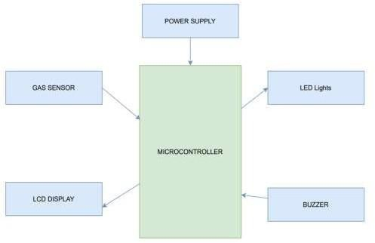

### MOTION CONTROLLED LED LIGHTS

**Fig 1.2**

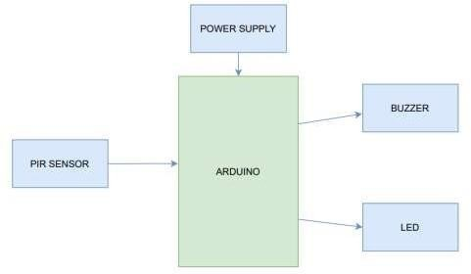

### PASSWORD BASED DOOR LOCK SYSTEM

**Fig 1.3**

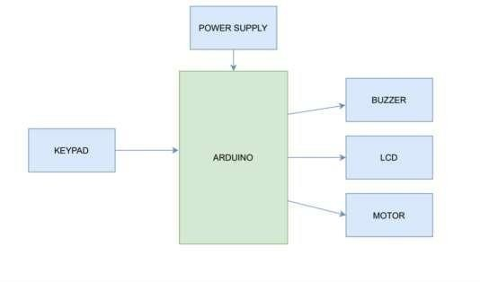

## CIRCUIT DIAGRAMS

### SMOKE DECTECTION SYSTEM

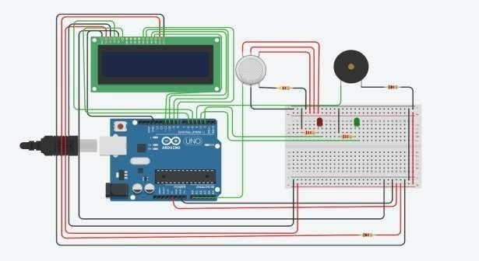

**Fig 2.1**

### MOTION CONTROLLED LED LIGHTS

**Fig 2.2**

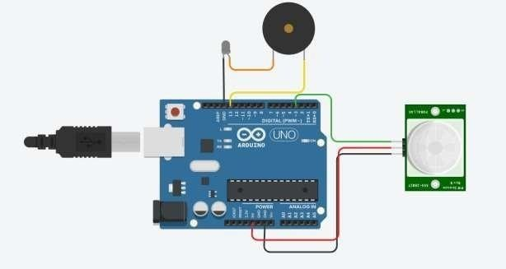

### PASSWORD BASED DOOR LOCK SYSTEM

**Fig 2.3**

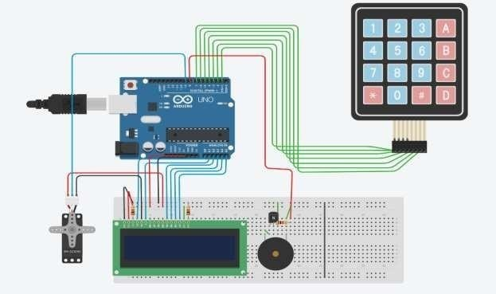

## CODES

### SMOKE DECTECTION SYSTEM

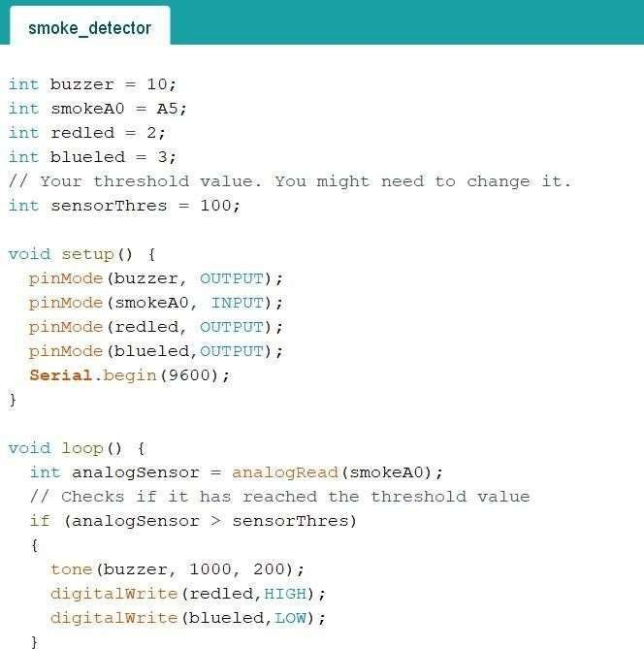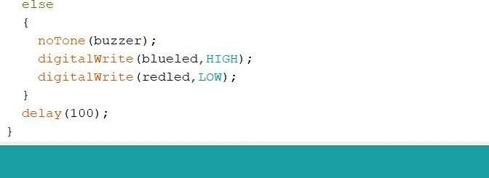

1. **MOTION CONTROLLED LED LIGHTS**

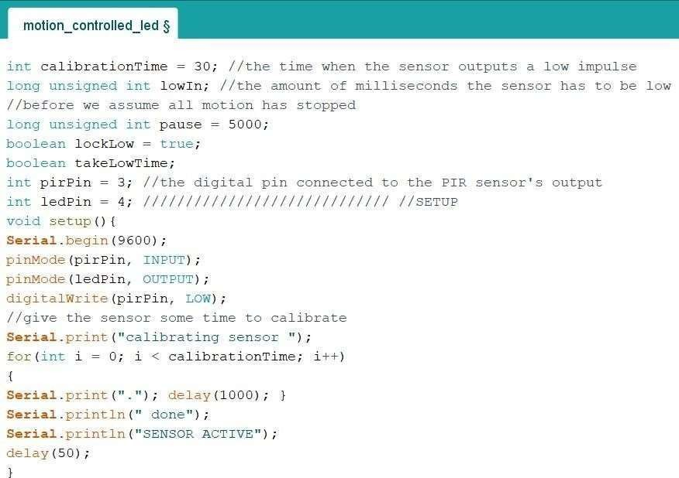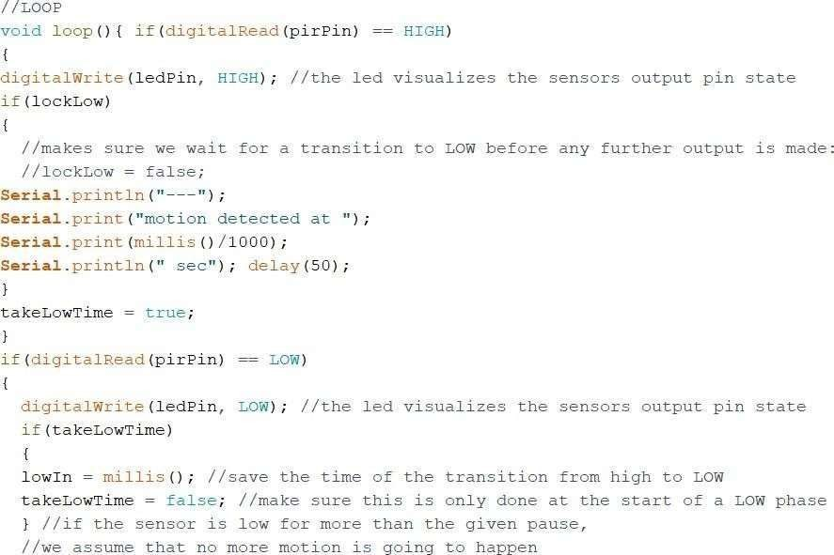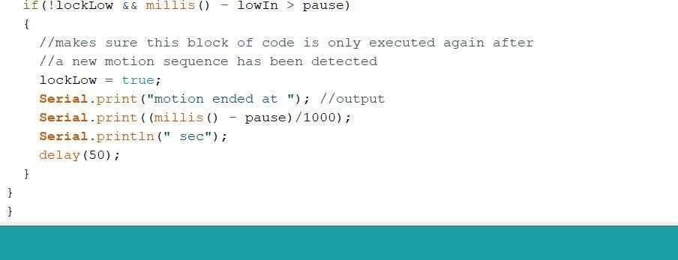

1. **PASSWORD BASED DOOR LOCK SYSTEM**

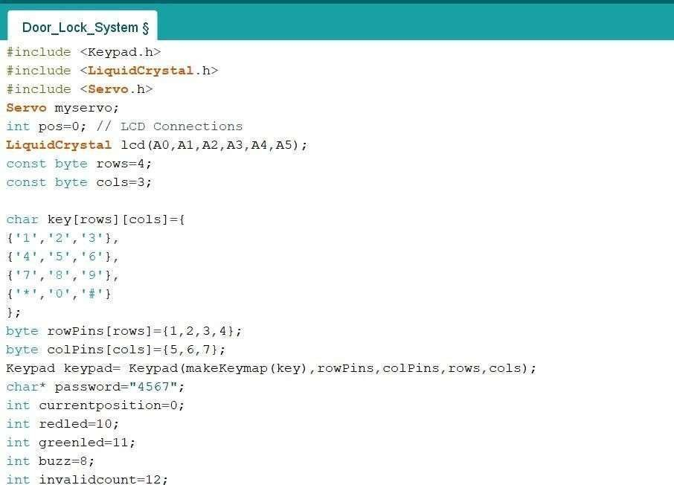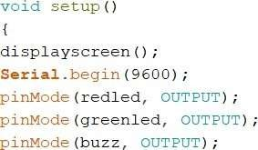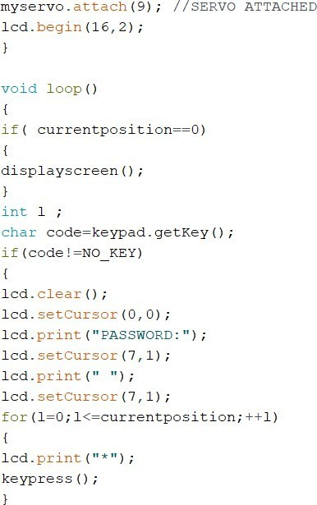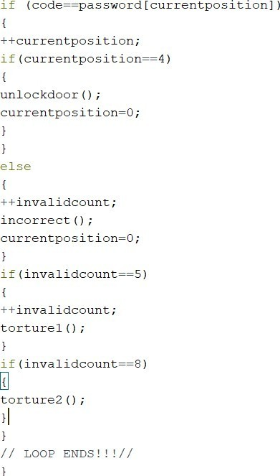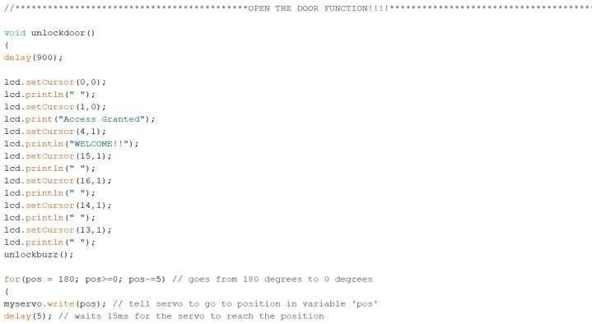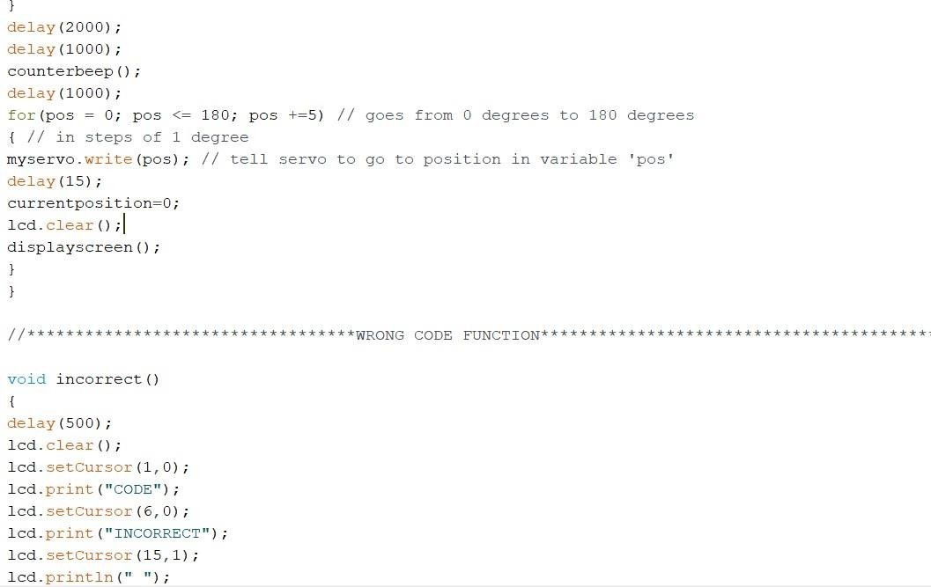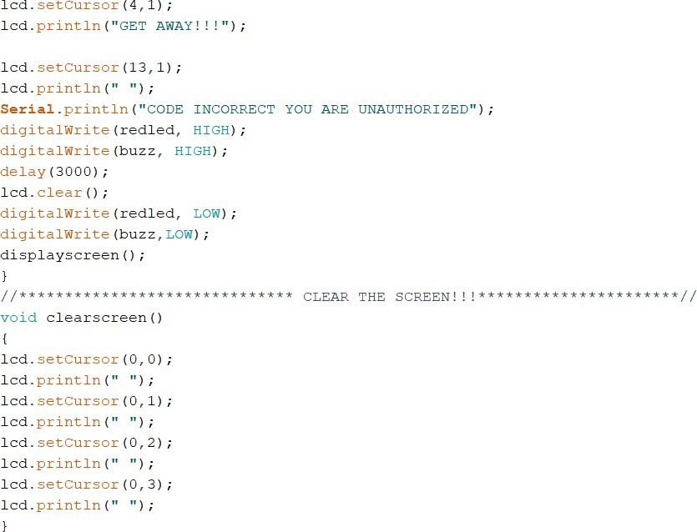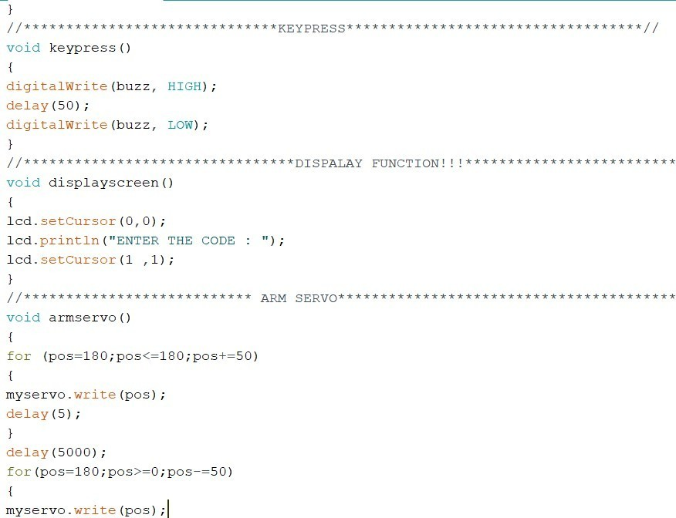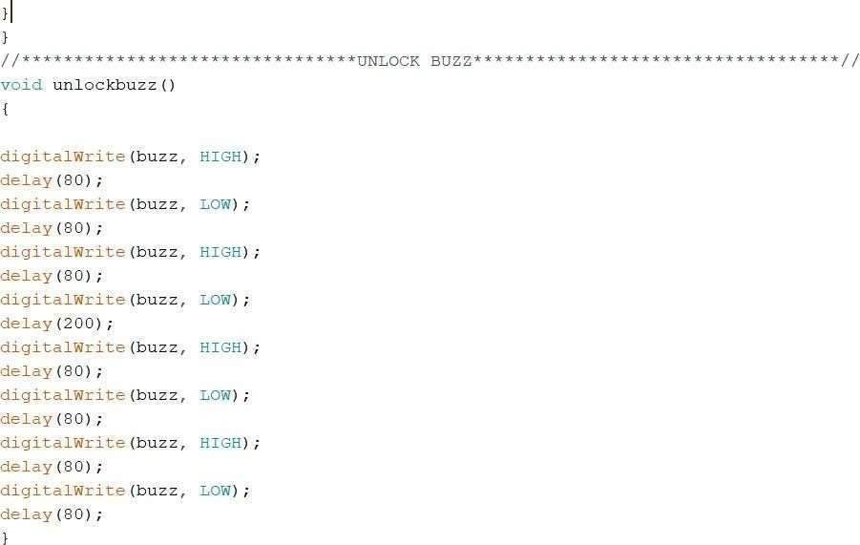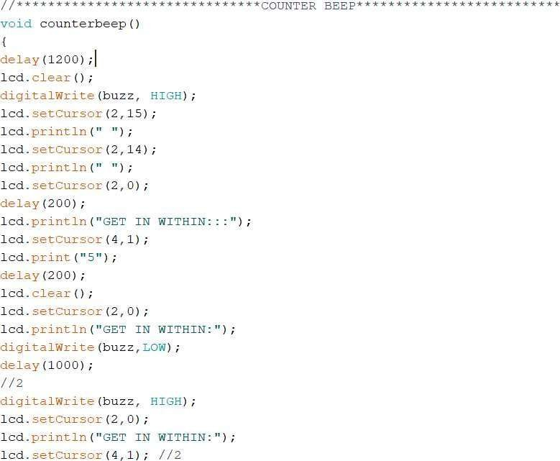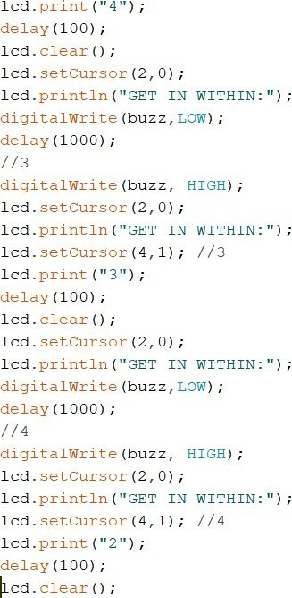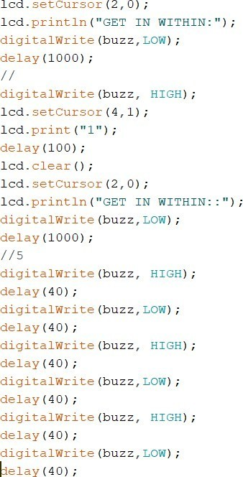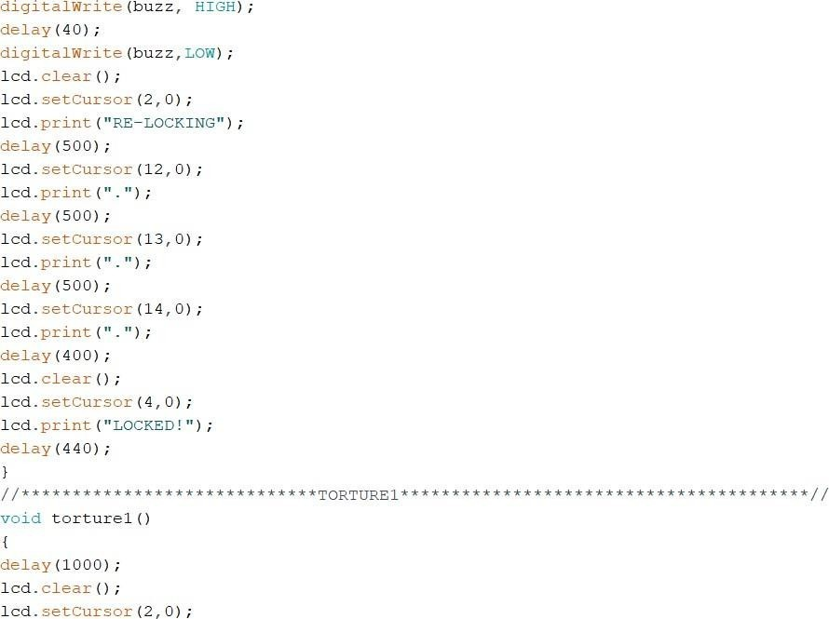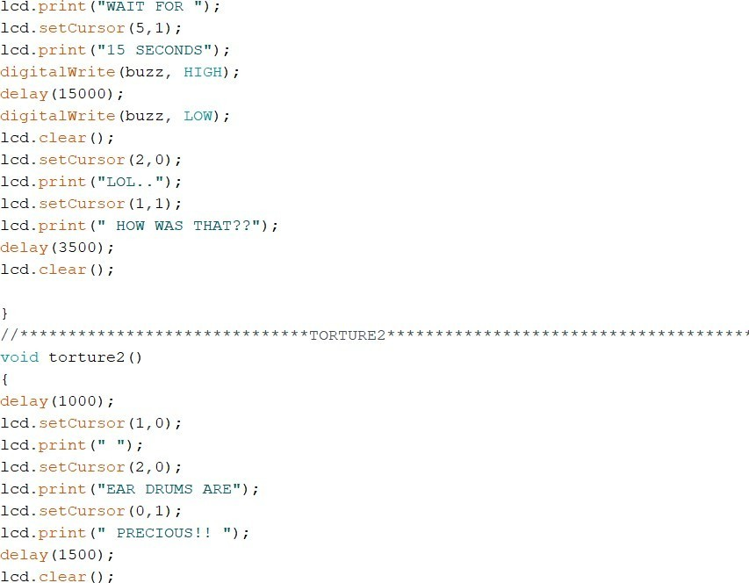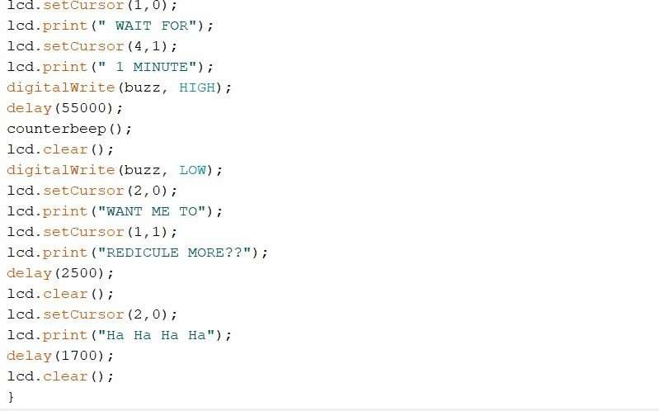

**CHAPTER 4**

# RESULTS

## OUTPUTS AND SCREENSHOTS

### SMOKE DECTECTION SYSTEM

#### (TINKERCAD)

* ***When Smoke is not Detected***, Green LED glows and no sound is produced by the buzzer. LCD display Messages “ALL CLEAR” & “SAFE”.

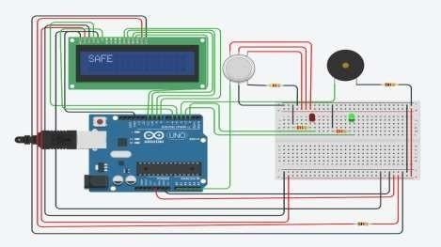

### Fig 4.1

* ***When Smoke is Detected***, Red LED glows and sound is produced by the buzzer. LCD display messages “ALERT” & “EVACUATE”.

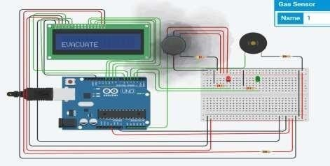

#### (HARDWARE)

* ***When Smoke is not Detected***, Yellow LED glows and no sound is produced by the buzzer.

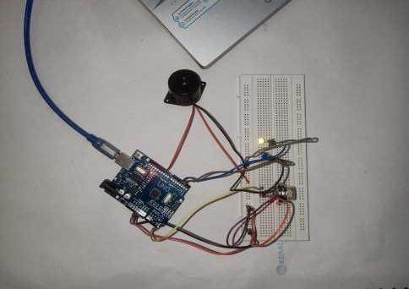

### Fig 4.3

* ***When Smoke is Detected***, Blue LED glows and sound is produced by the buzzer.

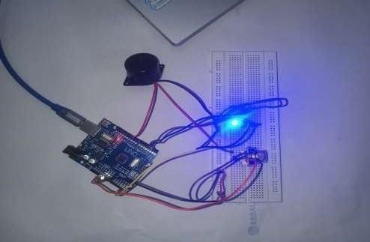

### MOTION CONTROLLED LED LIGHTS

#### (TINKERCAD)

* When an ***Object in Motion*** is detected By PIR SENSOR, Buzzer Turns ON & White LED glows.

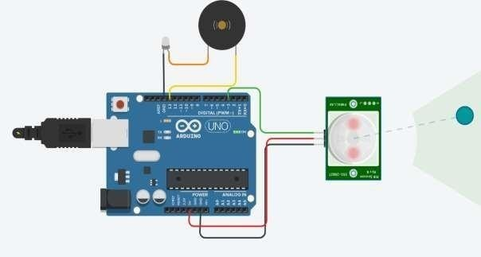

### Fig 5.1

* When an ***Object in not in Motion***, Buzzer Turns OFF & LED turns OFF.

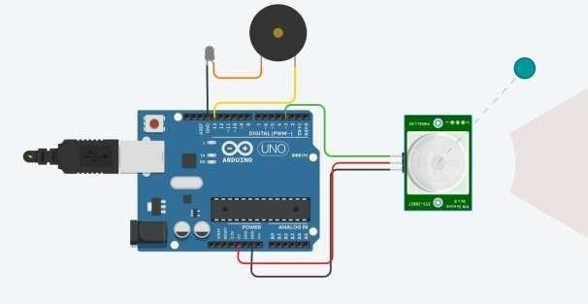

#### (HARDWARE)

* When an ***Object in not in Motion***, Buzzer & LED turns OFF

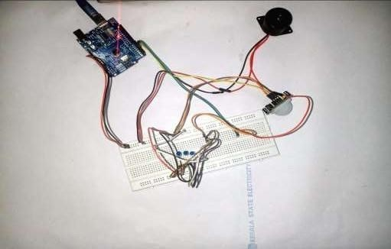

### Fig 5.3

* When an ***Object in Motion*** is detected By PIR SENSOR, Buzzer Turns ON & Blue LEDs glows

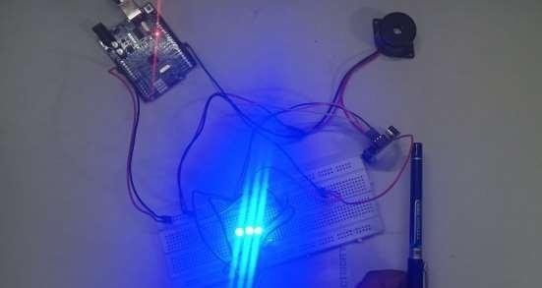

### Fig 5.4

1. **PASSWORD BASED DOOR LOCK SYSTEM**

#### (TINKERCAD)

* When code entered is wrong, “***CODE INCORRECT GET AWAY!”*** message is displayed & Buzzer Starts to make sound.

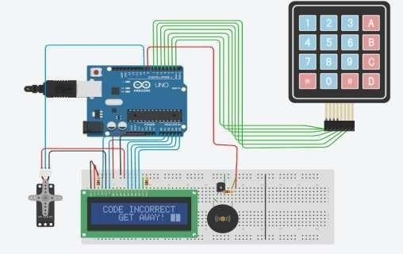

### Fig 6.1

* When code entered is right, “***ACCESS GRANTED WELCOME!”*** message is displayed.

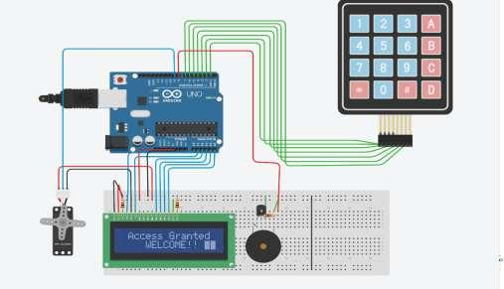

**Fig 6.2**

## APPLICATIONS

Home automation is becoming popular all over the world with each passing day. These systems are very convenient for people who have hectic schedules and do not get much time to carry the house hold activities. These systems are very compact and very much compatible for all kinds of people. Thought the middle class might find it expensive, the high class can easily afford buying and installing one at their home. The home automation system helps you control the devices at your home automatically. In order to change the settings of it you simply need to have a computer, android device with internet or remote control. In this way everything will work according to you wish. We have heard about smart phones and smart devices, by installing a home automation system you can very easily make your ordinary home a smart home.

Any day-to-day, repeatable process is automatable with smart home applications. The greater the control and flexibility of these processes, the more energy and cost savings the resident experiences, which are factors anyone who pays utilities strives to moderate. The smart home revolution is likely to be more of an evolution, with the incorporation of one or two home systems at a time, gradually automating our households through smart mobile devices.

The inefficiency of operation of conventional wall switches can be overwhelmed using various home automation systems (without using conventional switching methods). The loss of power can be reduced and manpower required for home automation is very less compared to conventional methods. The IR, RF, android application, Arduino, Bluetooth, DTMF, etc., based home automation systems can be more efficient, provides ease of operation. Provides safety from electrical power short circuits while using conventional wall switches to operate loads. Home automation system with automated door locking and security cameras facilitates more security. By using a home automation system, we can save a lot of time to operate home appliances from anywhere.

In this project we use micro-controller like Arduino help the consumer wirelessly control lights or automatically turn off lights in case no motion detected to save power consumption, a door lock keypad system to increase security in sensitive areas, and a fire alarm system one of the basic needs for almost all newly constructed buildings. Smoke detector system can be used offices, shops and homes to detect fires. It can also be used to detect alcohol content ignorer to check if people are drunk driving, detect the concentration of harmful and harmless gases in the atmosphere. Control lights using PIR sensors: Street lights, washrooms, places where light is required only when someone needs to pass by or use it for a very short period of time so electricity is saved. The smart door lock system can be used in homes, offices, and hotels. They provide a higher level of security as

compared to the locks used nowadays. It saves time as we don’t need a key to lock and unlock the door. It has better access control as we might lose physical keys or forget them.

## RESULT

Home automation can quickly bring the future in to our homes by incorporating security, climate, and household gadgets and transforms our regular home into a futuristic smart home. These smart home systems can be used for simple or elaborate tasks by integrating devices and gadgets inside and outside of your home. All Smart Home systems will use similar components. These enable it to perform different actions, to sense environmental conditions and to react to motion, doors opening, windows closing and all manner of different events in your home. Each device type has a specific purpose within the system, together they will give you the flexibility to control your home, and keep you informed about what’s going on. In Future, the wireless controlled lights, google assistant or any AI like Alexa, Siri can be integrated to control lights by voice commands, moreover we can implement face id unlock or finger print unlock to make the security harder to breach, in case of breach owner will receive notifications so that he /she can call the appropriate authorities, similarly in case of fire notification can be sent directly to the fire department and to the respective owner. The plant monitoring system can monitor plant health remotely based on the data stored by the system in cloud.

## CHAPTER 5 CONCLUSION AND FUTURE WORKS

### CONCLUSION

The main purpose of a home automation system is to provide ease to people to control different home appliances with the help of the android application present in their mobile phones and to save electricity, time, and money. Our Door Lock system helps the user to protect their homes from burglars when they are away from the home by using an alarm as the alarm will start ringing whenever a burglar tries to enter the house and the person will receive a message on his mobile phone whenever some other person will try to enter the owner’s house. In motion- controlled -LEDs help us to save a lot of electricity. This can not only be used in controlling LEDs but also can be fitted in taps to save water and avoid wastage. In Smoke detector System we were able to develop the software with minimum cost and the software helps people to detect smoke hence help them to extinguish the fire. This software can also be used as an alcohol content ignorer. So, in this project, we were able to make software that enhances home automation.

### FUTURE WORKS

The main purpose of a home automation system is to provide ease to people to control different home appliances with the help of the android application present in their mobile phones and to save electricity, time, and money. This system also helps the user to protect their homes from burglars when they are away from the home by using an alarm as the alarm will start ringing whenever a burglar tries to enter the house and the person will receive a message on his mobile phone whenever some other person will try to enter the owner’s house. In motion- controlled -LEDs help us to save a lot of electricity. This can not only be used in controlling LEDs but also can be fitted in taps to save water and avoid wastage. In Smoke detector System we were able to develop the software with minimum cost and the software helps people to detect smoke hence help them to extinguish the fire. This software can also be used as an alcohol content ignorer. So in this project, we were able to make software that enhances home automation.

## CHAPTER 6 REFERENCES

1. [http://ijeert.org/pdf/v3-i2/2.pdf,](http://ijeert.org/pdf/v3-i2/2.pdf) Implementation of Internet of Things for Home Automation, *Mamata Khatu, Neethu Kaimal, Pratik Jadhav, Syedali Adnan Rizvi.*
2. ,https://[www.irjet.net/archives/V2/i6/IRJET-V2I6133.pdf,](http://www.irjet.net/archives/V2/i6/IRJET-V2I6133.pdf) Home Automation Using Atmega328 Microcontroller And Android Application, *S.Anusha, M.Madhavi, R.Hemalatha* .
3. https://[www.researchgate.net/publication/337568027_Implementation_of_a_Cloud-](http://www.researchgate.net/publication/337568027_Implementation_of_a_Cloud-) Based_Home_Automation_System, Implementation of a Cloud-Based Home Automation System, *A. O. Otuoze, N. T. Surajudeen-Bakinde, A. T. Abdulrahman and O. H. Isiwekpeni .*
4. https://[www.ijcsmc.com/docs/papers/May2015/V4I5201599a70.pdf](http://www.ijcsmc.com/docs/papers/May2015/V4I5201599a70.pdf) , Raspberry Pie Home Automation with Wireless Sensors Using Smart Phone , *P BHASKAR RAO and S.K. UMA*
5. https://[www.arduino.cc/](http://www.arduino.cc/)
6. https://create.arduino.cc/projecthub/biharilifehacker/how-to-make-smoke-detector-alarm- 1c322b?ref=user&ref_id=1321915&offset=1
7. https://how2electronics.com/arduino-smoke-level-detector-using-mq-135-sensor/
8. https://[www.arduino.cc/en/Tutorial/LibraryExamples/LiquidCrystalDisplay](http://www.arduino.cc/en/Tutorial/LibraryExamples/LiquidCrystalDisplay)